Collateral Web Q4 2016 Release

November 2016 Release

Welcome to CW Version

Main areas of focus in this Collateral Web production release include:

* A FEMA Hyperlink for Flood Maps on the Building Panel (FCE/YKE/AgC ONLY)
* Purchased Participations Secured by Chattel (FCE/YKE ONLY)
* Lien Position Configurable by ACA (FCE/YKE ONLY)
* The Ability to Edit Loan Position from Collateral Analysis Screen
* Editable Content of Partial Releases
* Tax Season IRS Requirements for Real Estate Collateral

FPI Credit Products

November 12, 2016



**Table of Contents**

Collateral Web Q4 2016 Release 1

Flood Maps 2

Lien Position 4

Lien Position Configurable by Association **(FCE/YKE ONLY)** 4

Collateral Analysis Screen 5

Loan Position Editable on Collateral Analysis Screen **(FCE/YKE ONLY)** 5

Partial Releases 6

Editing Content of Partial Releases 6

Purchased Participation Loans 10

Purchased Participation Loans Secured by Chattel **(FCE/YKE ONLY)** 10

IRS Requirements 11

Resolved Items 11

Flood Maps

FEMA Hyperlink for Flood Maps **(FCE/YKE/AgC ONLY)**

Previously in Desktop EmPOWER, a hyperlink was available in LOS that brought you to the FEMA Determination site. This hyperlink is now available in Collateral Web for Farm Credit East, Yankee, and AgCountry. Each association will be directed to the following sites:

* Farm Credit East: <http://www.interflood.com/>
* Yankee: <http://www.interflood.com/>
* AgCountry: [https://lender.floodapp.com](https://lender.floodapp.com/)

In Farm Credit East, on the **Check All That Apply** panel, indicate that “The property includes buildings or improvements”. The **Search Flood Maps** hyperlink will then appear on the **Buildings** panel.

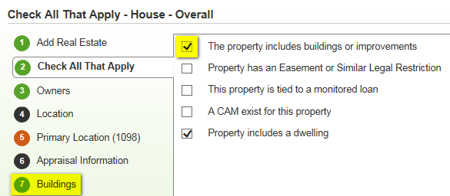

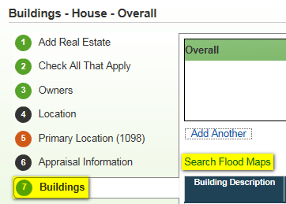

In Yankee, the **Search Flood Maps** hyperlink will appear on the **Buildings** panel.

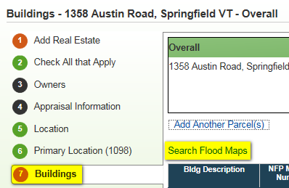

In AgCountry, **Search Flood Maps** will appear on the **Buildings & Improvements** panel.

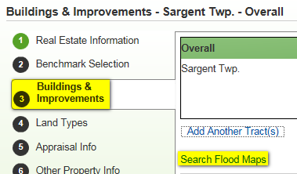

Lien Position

## Lien Position Configurable by Association **(FCE/YKE ONLY)**

In Farm Credit East and Yankee, **Collateral Web will no longer default lien position**. Previously, in a scenario with multiple security documents, linking collateral to an existing security document would default the lien as “2nd position”. You would then need to change it back to 1st position.

When collateral is linked, **lien position will no longer be displayed**. This change will prevent you from having to continually update lien position for each collateral relationship, resulting in greater productivity and efficiency.

In the example below, linking the Real Estate to Security Document 10/06/2016 (on the left) will display the Smart Link Wizard without the lien position. Select **Save** to finishing linking the collateral.

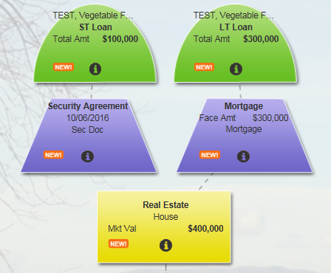 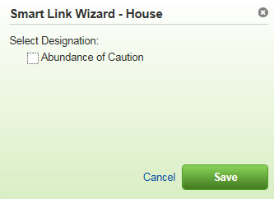

Collateral Analysis Screen

## Loan Position Editable on Collateral Analysis Screen **(FCE/YKE ONLY)**

You can now edit loan position from the Collateral Analysis screen. Previously, it was a requirement for security documents to be linked to collateral when setting loan position. However, security documents do not factor into the position each **loan** is in.

This enhancement will allow you to stay on the Collateral Analysis grid. You no longer have to navigate to the Collateral View screen to make these changes.

To edit loan position on the Collateral Analysis grid, hover your cursor on the loan you would like to edit. This will display the **Update Relationship** menu. Selecting the menu will display the screen to edit loan position. Select **Save** to complete.

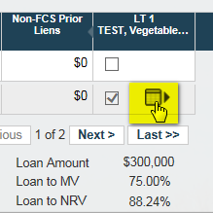 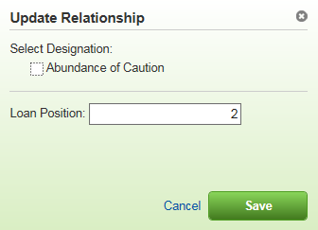

Any changes made to loan position will display on the Collateral Analysis grid.

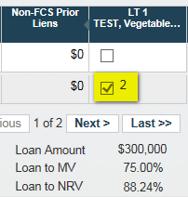

Partial Releases

## Editing Content of Partial Releases

## Previously, once a partial releases was saved, it could not be modified. To make any changes, the collateral would have to be deleted and re-entered. Now you will be able to go into the **Partial Release** **History** and edit the release without losing any work.

Under the **Partial Release History** tab, every release will be displayed. The **edit** hyperlink appears to the left of each release. You may also **delete** summary level partial releases.

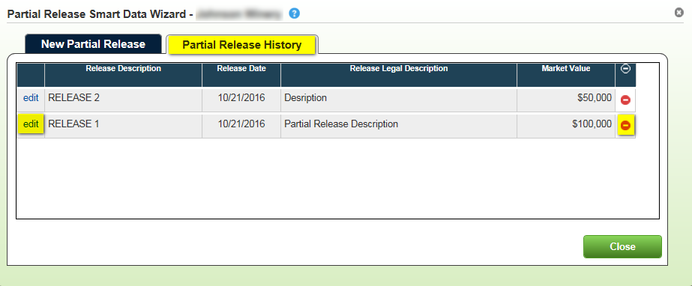

Selecting **edit** allows you to make changes to the **Release Description, Release Legal Description, Release Date,** and **Market Value being released (summary level).**

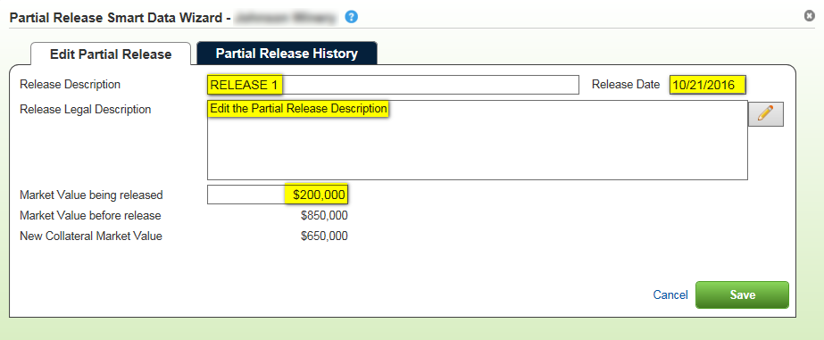

For collateral with detail records, you cannot enter a specific market value as you can at the summary level. Selecting a detail record for a partial release will release the entire value of the detail.

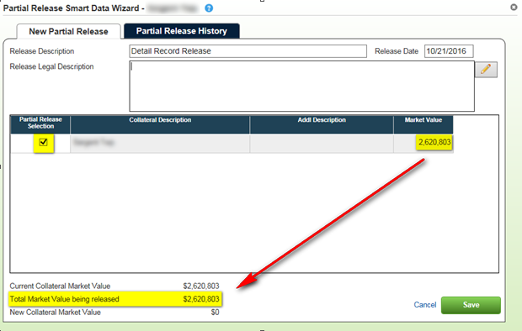

If you want to release only a portion of a detail record:

1. Create an additional detail record for the amount that will **NOT** be released
   * Example: The value of the collateral after the partial release should equal $1,000,000
2. Perform a partial release of the **original** detail record

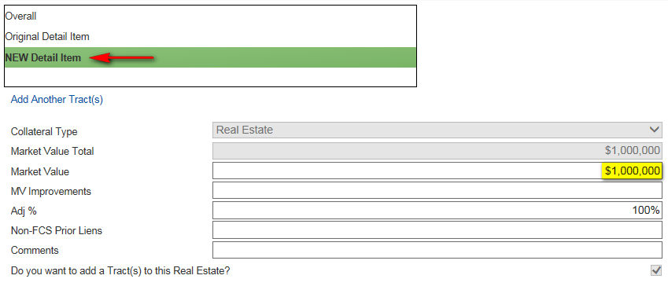

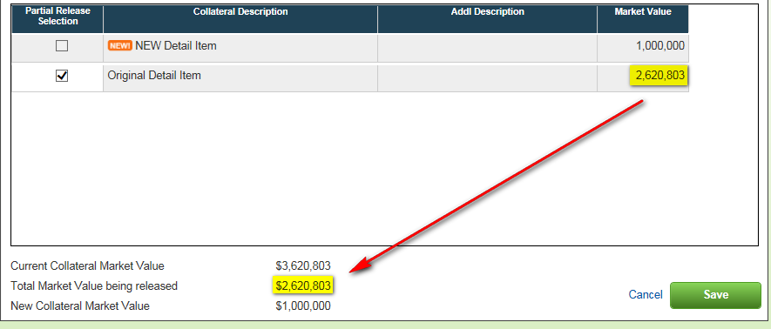

For **new collateral** or **new detail records** under existing collateral, you will **not** be able to do a partial release. If you need to change the market value, you can do so by selecting Edit Details.

On the detail items menu, the Partial Release Selection will be grayed out. A **NEW!** icon will appear as a notification.

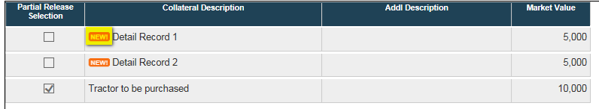

On new collateral objects, Partial Release will not appear as an option on the drop-down menu.

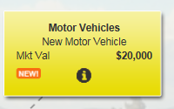

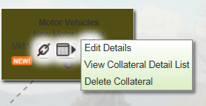

Partial Releases of Zero Value

In the event that you want to release a portion of collateral but do not want to release any value associated with it, you can now enter $0 as the Market Value being released.

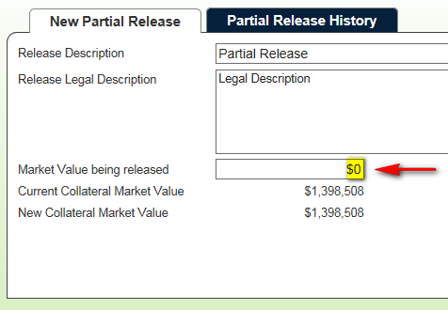

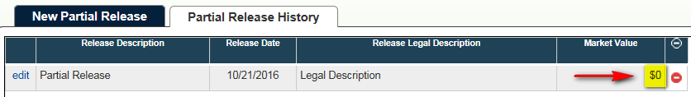

Purchased Participation Loans

## Purchased Participation Loans Secured by Chattel **(FCE/YKE ONLY)**

For Farm Credit East and Yankee, purchased participations are categorized as “long-term loans” in Collateral Web. Normally, chattel is not factored into the L/MV% for a long-term loan. This enhancement will allow chattel to be calculated for purchased participations.

In the below example, the $2,000,000 purchased partifipation is a long-term loan secured by $10,000,000 of chattel. The L/MV% is calculated as 20.00%.

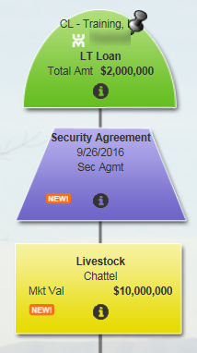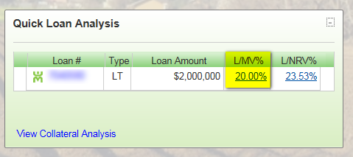

Long-term loans that are **not** purchased participations will continue to have L/MV% calculated as zero.

IRS Requirements

Tax Season IRS Requirements for Real Estate Collateral

In 2016, Form 1098 is required to be filed by any individual engaged in a trade or business who received $600 or more of mortgage interest on any one mortgage during the calendar year. [2016 Instructions for Form 1098](https://www.irs.gov/pub/irs-pdf/i1098.pdf) can be found by clicking the hyperlink.

Location

On the Location panel, all addresses in EmPower for for the customer’s group will appear under **Existing Addresses**.Highlight the address and select the **Add Location w/ Selected Address** hyperlink.

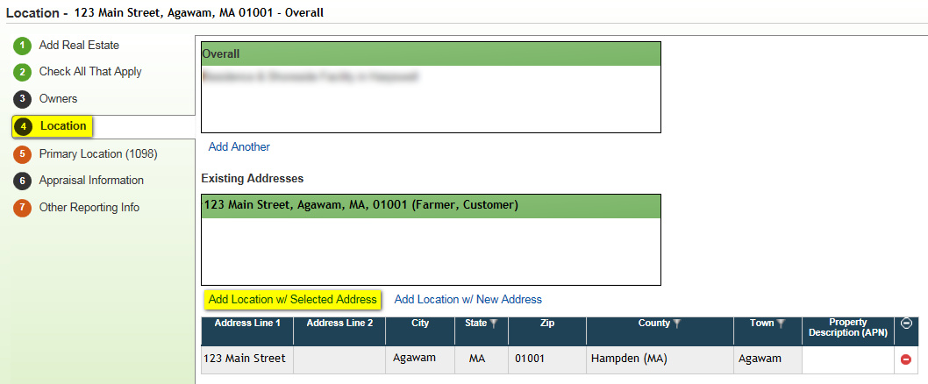

Addresses selected in this manner will be read-only. Changes to this address can only be made in EmPOWER. If the address being edited is the primary for the 1098, EmPOWER will provide a warning that the address of collateral is being changed. This will be effective after the 2017 Q1 EmPOWER release.

Should the same address is listed more than once, the customer’s name in which that address is entered for in EmPOWER will appear in parenthesis. This is intended to identify which address belongs to which customer.

# If the primary address is not listed under existing addresses, select **Add Location w/ New Address**. You may then enter an address in the text field.

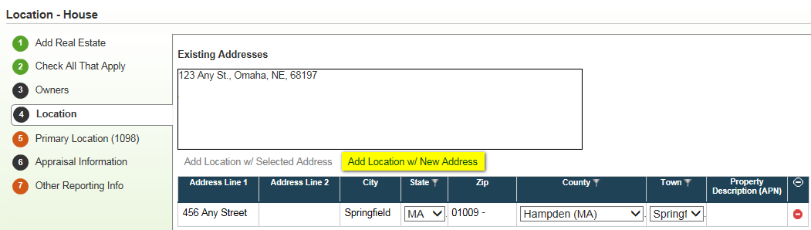

# The address must include **address line 1, city, state, and zip**. If the real estate does not have an address, **Property Description (APN**) with the **county and state** will be required.

Primary Location (1098)

# For all associations ***except*** Northwest, once an address has been added, navigate to the **Primary Location (1098)** tab. Indicate the primary address for Form 1098 by selecting the radio button to the left of each address. The first address in this list with be selected by default.

# 

In **Northwest ONLY**, the primary address for the 1098 is indicated on the **Location** panel.

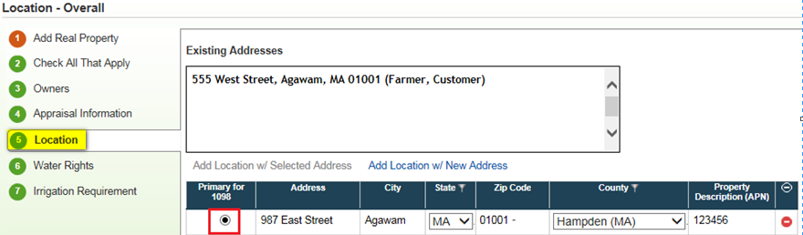

Note: In some cases, a single piece of collateral may have multiple detail records securing multiple loans. Each detail record may have a different primary address. If so, you must split the collateral using a **Split Tract.** You may then select the primary address for each collateral object.

Business Rules for Invalid Address

If you attempt to **submit or validate** a scenario with an invalid address in the Location panel, select an invalid address as the primary location for the 1098, or do not include any address, you will receive the following **soft** errors:

**Invalid Address in Location Panel:**

* “Collateral ‘House’ requires Other Reporting Information to be completed.”

**Invalid Address Selected as Primary for 1098:**

* “The Primary Location for Real Property Collateral ‘House’ does not have either a valid mailing address, or a Property Description with County and State information. This is required for IRS reporting.”

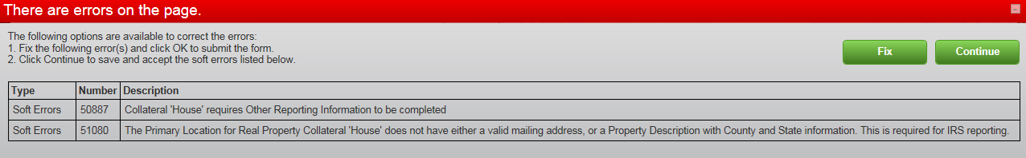

**You will still be able to submit the scenario and book loans, as needed.**

Resolved Items

| ID | Summary Description | Detail Description/Resolution | INC # | FCE | YNK | FCW | NW | AgC | CoBank |
| --- | --- | --- | --- | --- | --- | --- | --- | --- | --- |
| 89509 | 2016 Tax Season IRS Requirements for Real Estate Collateral | On the locations tab, there are requirements for address information, as well as a radio button to indicate which address is the primary for Tax Form 1098 |  | X | X | X | X | X | X |
| 92340 | Add FEMA Hyperlink for flood maps | FEMA Hyperlink for flood maps will appear on Buildings Panel. You will be forwarded to the appropriate |  | X | X |  |  | X |  |
| 92360 | Lien position configurable by association | Lien Position will no longer default in scenarios with multiple security documents |  | X | X |  |  |  |  |
| 92961 | Partial Releases editable | On the Partial Release History tab, you can edit Release Description, Release Legal Description, Release Date, and Market Value being released (summary level) |  | X | X | X | X | X | X |
| 92363 | Ability to edit loan position from Collateral Analysis screen | The “Update Relationship” menu will appear on the Collateral Analysis grid. Loans can be set with an AOC or have loan position changed |  | X | X |  |  |  |  |
| 96782 | Partial Releases can have a value of zero | At the summary level, you can enter $0.00 as the market value being released |  | X | X | X | X | X | X |
| 96859 | Radio button for 1098 on Location panel | Due to NW not having detail on the Location panel, the radio button to indicate the primary address for the 1098 will appear on the Locations panel |  |  |  |  | X |  |  |
| 106868 | Identify customers name in Existing Addresses of Location panel | For each address that is pulled from EmPower, the customer’s name will appear in parenthesis next to each address |  | X | X | X | X | X | X |

If you have any questions, please reach out to the [FPI Credit Support](mailto:FPICreditSupport@financialpartners.com) team. If you need immediate assistance, please contact the FPI Customer Center of Excellence by phone at (800) 880-1577 or by email at: [customer.support@financialpartners.com](mailto:customer.support@financialpartners.com).